**Learners have to come up with a Report to support the answers to the following questions and suggestions.**

**Objective Questions:**

1. In analysing the dataset with Power BI, ensure data cleaning to address inconsistencies and missing values before further analysis.
   * 1. Removed all the empty rows and columns.
     2. Added a custom column to replace all the empty cells of reason for returned orders with “Not mentioned”
     3. Added a new column to calculate the number of days taken to deliver the order
2. How can we calculate the total revenue generated by all the sales?

**Visualization:**

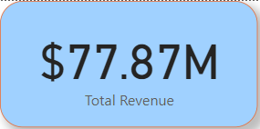

**Inference:**

* Drag the sale price into the chart and use a card to display the values.
* Considering that the refund would have been issued for all the returned orders, filter the revenue only for the delivered order.

1. What is the total number of unique customers who made purchases in each year? Is there any increase in the number over the years?

**Visualization:**

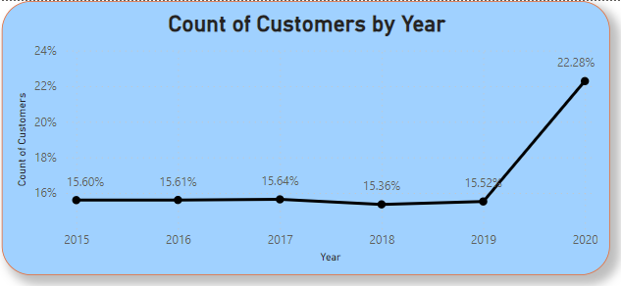

Inference:

* + - Number of customers that have made purchase from 2015 to 2019 is nearly the same.
    - The number of customers that have purchased in the year 2020 has seen a tremendous growth of 25.2K customers which contributes

1. How can we determine the total number of unique products available in the company?

Visualization:

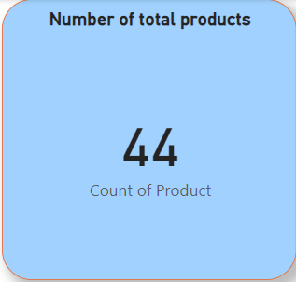

Inference:

By using the card visual, it is clear that there is data about 44 distinct products in the dataset.

1. What is the average number of days it takes for products to be delivered, get the metric for only the delivered orders?

Visualization:

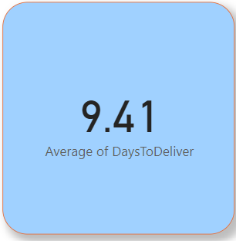

Inference:

The average number of days taken for one order to get delivered for only the delivered orders is **9.41 days**

1. Which products, categories, and subcategories are the most popular?

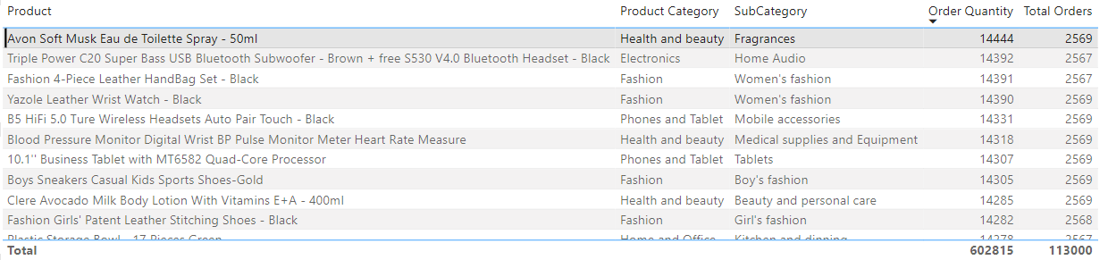

**Avon Soft Musk Eau de Toilette Spray – 50ml** from the Health and beauty category is the most popular product with a **14444** quantity ordered in **2569** orders generating a total revenue of **$739,440**.

1. Which products have seen an increase or decrease in sales over the year?

**Visualization:**

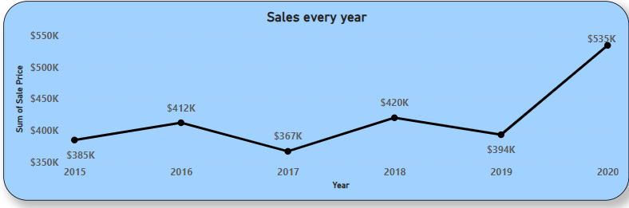

**Inference:**

* There has been increase and decrease in sales for all the products over the years.
* But in common, all the products were bought more in 2020. Reason could be because of the pandemic.

**Subjective Question:**

1. How does revenue break down by year and by-product? Evaluate how different products contribute to annual revenue and come up with suggestions to increase the sales of the low-selling items.

Visualization 1:

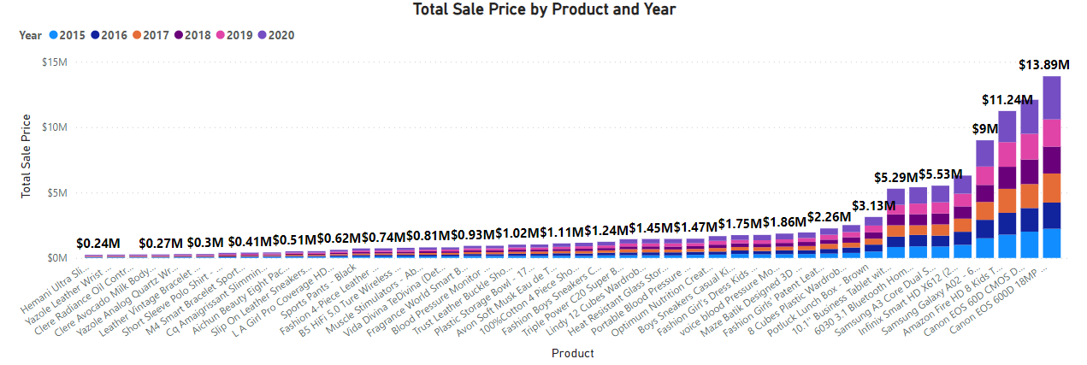

Visualization 2:

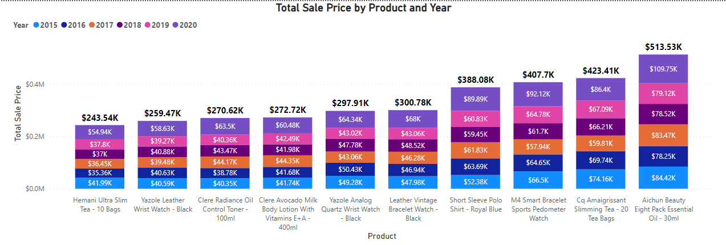

Inference:

* “Visualization 1” depicts the total sales done by each product in each year. The most sold product being **“Canon EOS 600D 18MP CMOS DSLR Camera - Black”** contributing **12.95%** of the total sales and least sold product being **“Hemani Ultra Slim Tea - 10 Bags”** contributing to **0.01%** of the total sales.

Recommendations:

* “Visualization 2” zooms into the bottom 10 products which were least sold and the management can find ways to promote those products in order to gain more profit.
* One way to do so, is to promote more on the gender group who uses the product more via social media

1. How many products were returned? Examine the possible reasons for returns and consider how this metric could inform improvements in product descriptions or quality control.

Visualization:

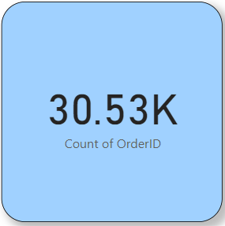 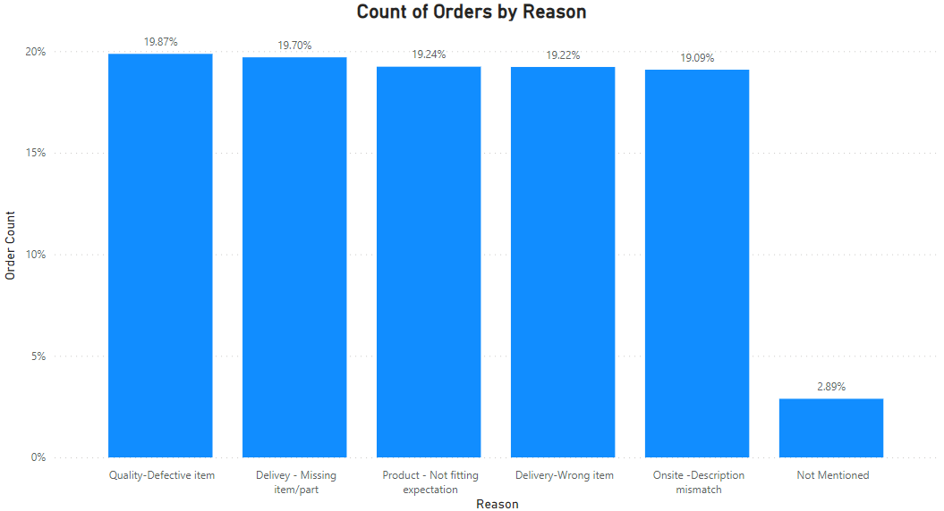

Inference:

* There are totally 30.53K orders returned which is 26.85% of the total orders received.
* Most of the orders where returned due to Quality or defective items which contributes to 19.87% of the total returns.
* 2.89% of the total returns did not mention the reason for the return.

Recommendations:

* The management has to send the products in a well-protected container so that the number of returns will be reduced.
* It has to make sure that all the parts for the product is packed together while shipping them and also has to make sure that the right product is being shipped to the customer.
* The management can make it compulsory to give a reason for the return or otherwise charge a penalty from the customers for returning without a reason. This will make our analysis a little more precise.

1. Whenever a customer goes to Amazon, they’ll filter the most rated products in order to buy the better category. Can you verify this using any visualization or table that the ratings of products impact their sales value?

Visualization:

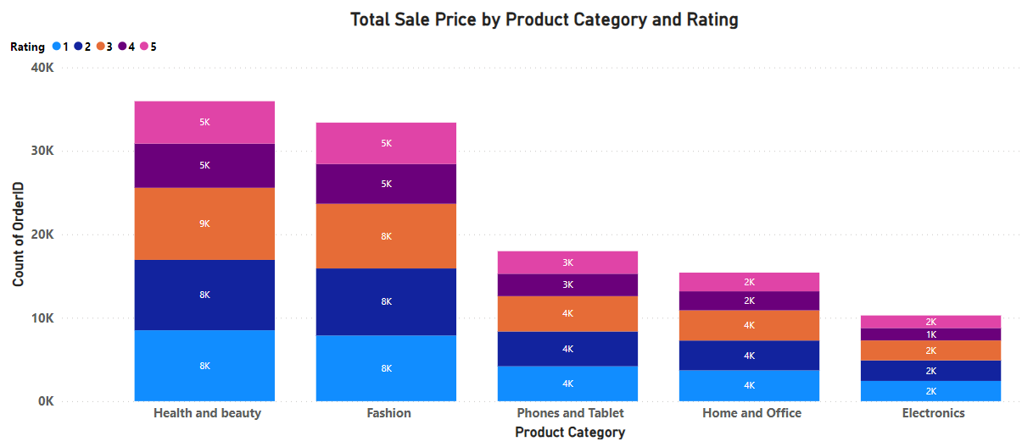

Inference:

* + Rating of 1,2 and 3 have been given to most of the products in each category which accumulates to 79K orders.
  + Rating of 4 and 5 have been given to only few of the orders in each category which only accumulates to 33K orders.

Recommendation:

* + The management has to be a little more careful while letting the sellers sell their product in their website.
  + Ratings could define the quality of the product.
  + If they see less ratings given by the customers continuously to the product, that product has to be removed from the site so that customers get to see only the products with good quality.

1. Investigate how revenue distribution varies across different locations. Explore which geographical areas contribute most to sales and consider the strategic implications for regional marketing and distribution efforts. How might location-based trends inform the company's approach to market segmentation and resource allocation?

Visual 1: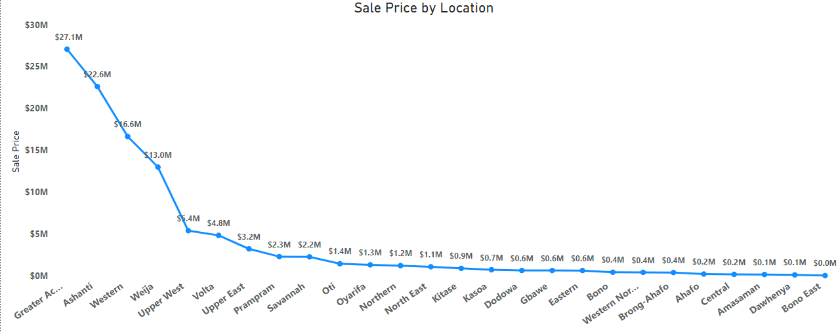

Visual 2: 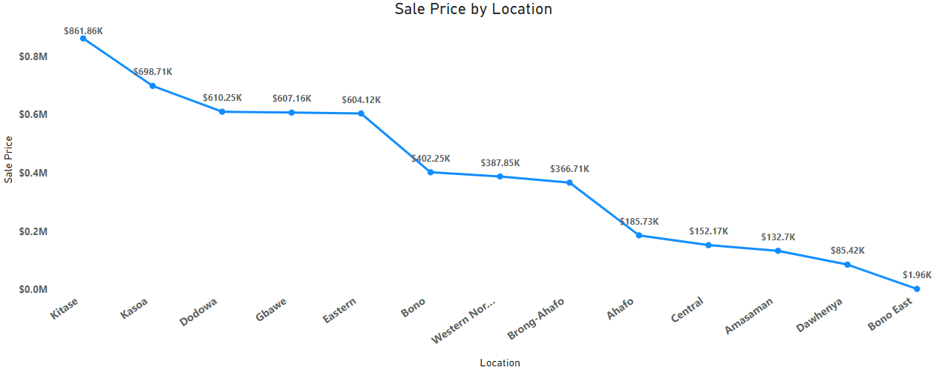

Inference:

* Visual 1 depicts the total revenue generated from each location.
* Greater Accra contributes to the most revenue generated with $27.1M and Ashanti contributes to the second highest revenue with $22.6M.
* Visual 2 represents the locations where the total revenue generated is below $1M.
* Bono East has contributed only $1.96K of total revenue so far.

Recommendation:

* To promote in the locations where there is less revenue, the management has to identify more about the location, if there are products that will be required seasonally, those products have to be promoted ahead of that season through televisions, newspapers and social media.
* Considering only the youth are aware of the social media, to indulge people of all the age category, it is a must to promote products in newspaper and televisions as well.

1. Determine which month could benefit from enhanced promotional offers to boost sales. Can you suggest some targeted marketing strategies here?

Visualization:

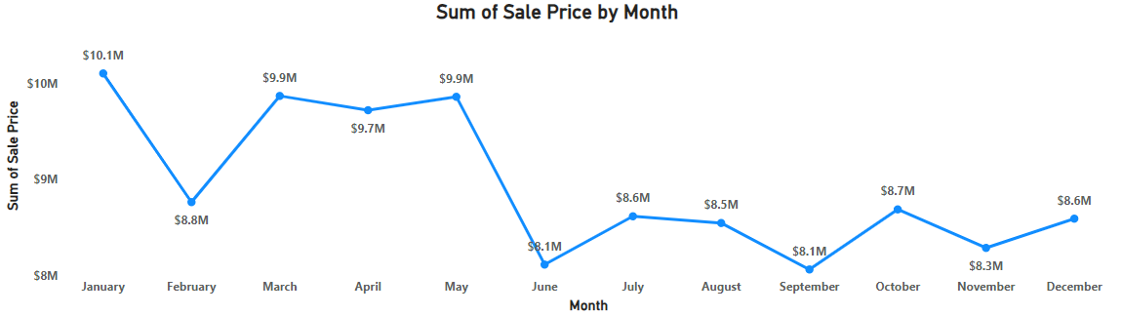

Inference:

* + The most revenue has come from the month of **January** with a whopping **$10.1M**.
  + The least revenue has come in the month of **June** and **September** with a revenue of **$8.1M** in each month.
  + There has been a **dip** in the revenue generated from **January to February** make a difference of **$1.3M** in sales.

Recommendation:

* Since February month is a winter month, the management can advertise about the new arrivals of the clothes that will be needed in winter.
* Accessories like sun glasses, sunscreen and hats could be promoted in the months of June, July and August due to summer.

1. Identify which products may require increased marketing efforts. Which items have high prices yet underperform in sales?

Visual 1:

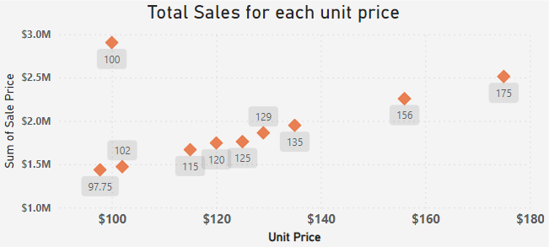

Visual 2:

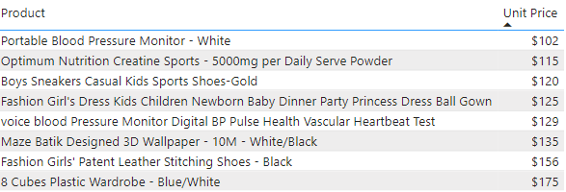

Inference:

* A product with a unit price of $100 generates a revenue of nearly $3M.
* Any product that cost between $100 and $200 does not generate a profit more than $2.5M
* Visual 2 represents the product list whose unit price is between $100 and $200.

Recommendation:

* The management has to concentrate on selling the products in the “Visual 2” more as it can generate more revenue to them.
* For example, to sell “8 Cubes Plastic Wardrobe – Blue/White” more, we can advertise them by targeting people between age of 25-50.

1. Assess which products should have discounts. How can targeted incentives drive sales and customer loyalty for specific products?

Visualization:

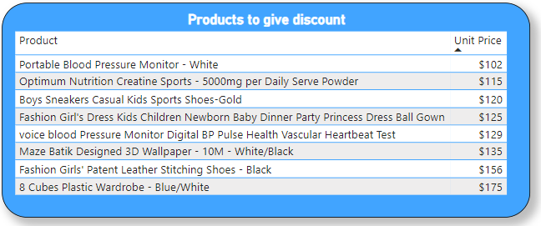

Inference:

* The list consists of products whose unit price is between $100 and $200.
* The products in this list does not generate a revenue of above $2.5M in total.

Recommendation:

* The management can include a discount up to 5% from the unit price.
* This will make the customers want to buy more.

1. Come up with a loyalty program to benefit the company’s customers. From the available lot of customers come up with strategies to bucket them and provide benefits under different loyalty programs.
2. **Wait Times Correlated with Demographics and Care:** Explore how average wait times vary across different product categories to optimize scheduling and staffing.

**Visual 1:**

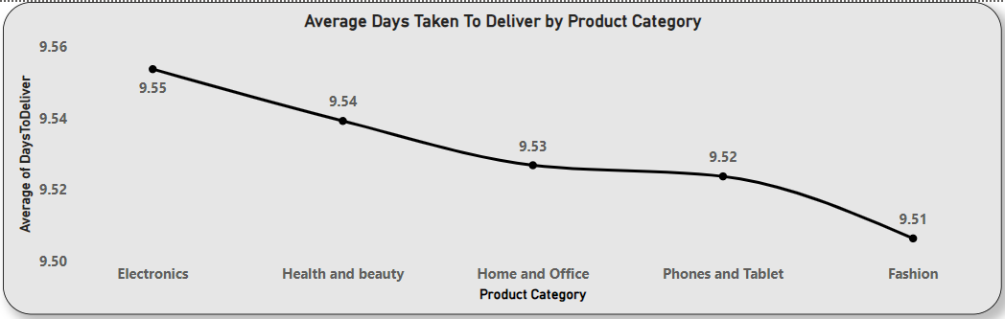

**Visual 2:**

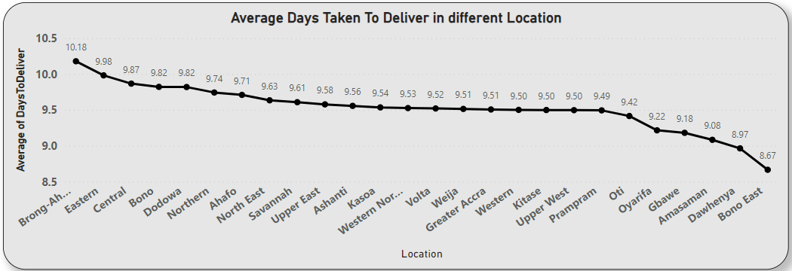

Inference:

* Visual 1 indicates the average number of days taken to deliver the orders based on their order category. There isn’t much of a difference between them.
* Visual 2 represents the average number of days taken to deliver according to location.

Recommendation:

* Since all the product category take similar time to get delivered, it is not right to come to any decision based on only that.
* A product gets delivered to Bono East in 8.67 days but takes 10.18 days to deliver a product in 10.18. So, the management has to find an optimized route to deliver the order at a much faster time.

1. Explore if there is any relationship between the Delivery type and waiting time between ordering and receiving an item.

Visualization:

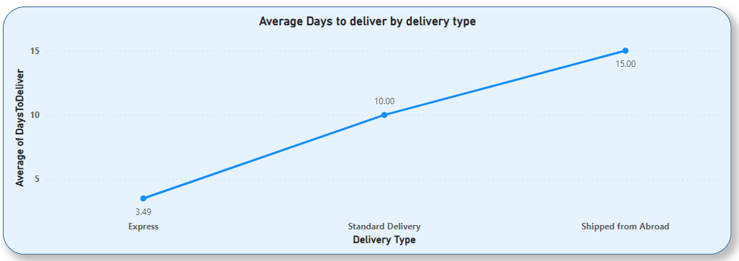

Inference:

* Express delivery type seems to deliver the product in 3.5 days per order.
* Whereas, shipping an order from abroad seems to take 15 days to reach the customer.

Recommendation:

* To make the customers subscribe for the express delivery, the management can provide a small discount on the subscription or an extension on the subscription.
* For example, if the customer subscribes for a year, the management can provide an addition of one-month express delivery.

1. Is there any relationship between shipping charges and product type?

Visual 1:

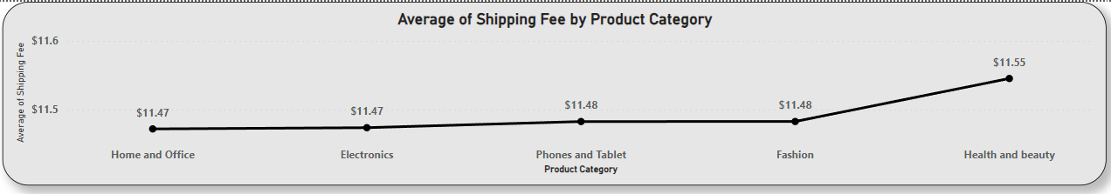

Visual 2:

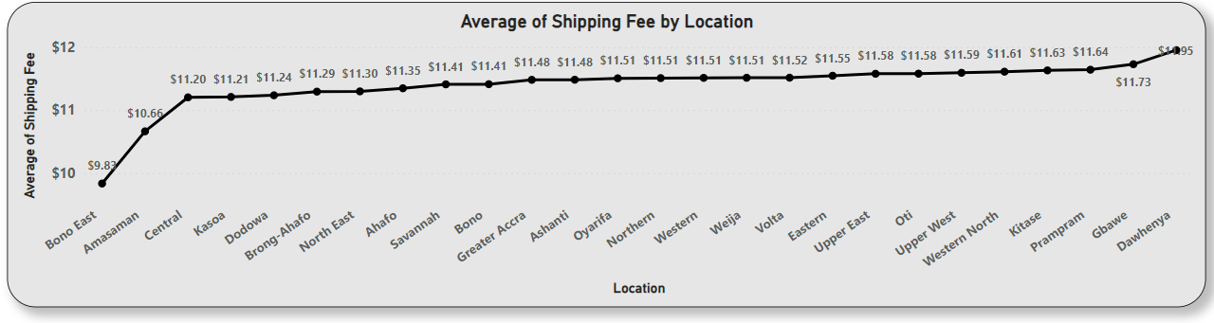

Inference:

* Visual 1 shows the shipping fee product category wise. There is no relation between the shipping fee and product category as we can see from the graph. All the categories seem to have the similar average shipping fee.
* Whereas there is relation between the location and the shipping fees and it is visualised in the second visual.
* The least shipping fees is charged for the products being delivered to Bono East at a cost of $9.83, and the maximum average shipping fees is charged for the products being delivered to Dawhenya at a cost of $11.95.

Recommendation:

* The business can ship more products all together if it is being shipped to the same location by charging the same shipping fee.
* This way it can make sure it spends less amount on shipping charges and gain more profits than before.

1. Come up with strategies to decrease the low rating orders after analyzing different factors like waiting time, shipping type, unit price, etc.

The stakeholders have asked for three tabs in the Reporting:

* Main Tab
* Product Tab
* Individual product Tab
* Using the Main tab in the Report, Stakeholders should be able to look at the number of total sales, revenue produced by till now and customer satisfaction for all product category. This tab should have a slicer of product category and date.
* Using the product Tab, the management at the company should be able to look at the individual product category-wise performance like customer satisfaction, number of customers purchasing that product, and which product requires improvement. This tab should have a slicer of gender, delivery type, product category and age group
* Using the Individual product Tab, the Management and Stakeholder in the company want to look at the best product profile which would involve their total purchase, id of that product, category/subcategory of that product, average rating, and how much revenue was generated by this product. Basically, all the metrics using which they can address the product very carefully in their orders.

**Main Tab:**

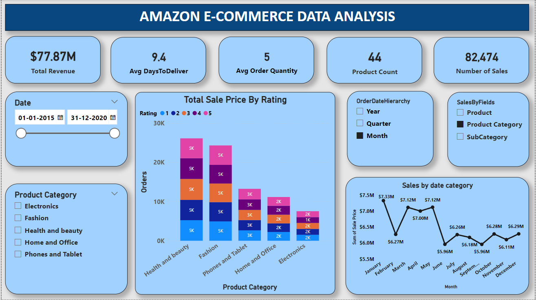

**Product Tab:**

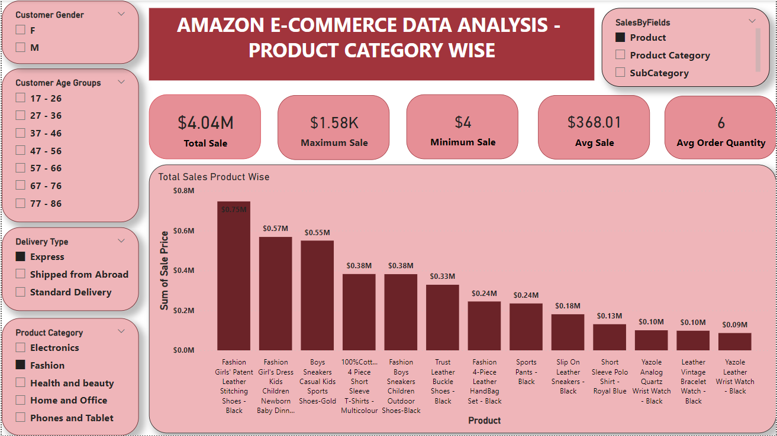

**Individual Product Tab:**

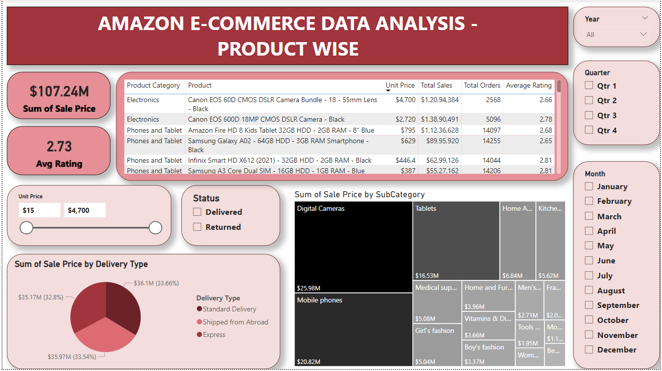

**Make sure that all the visualizations look decent and are placed in a proper order. There are different POCs (Point Of Contact) for each tab, so make sure you involve all the metrics that POC may look at in that tab along with those mentioned in the tab description.**